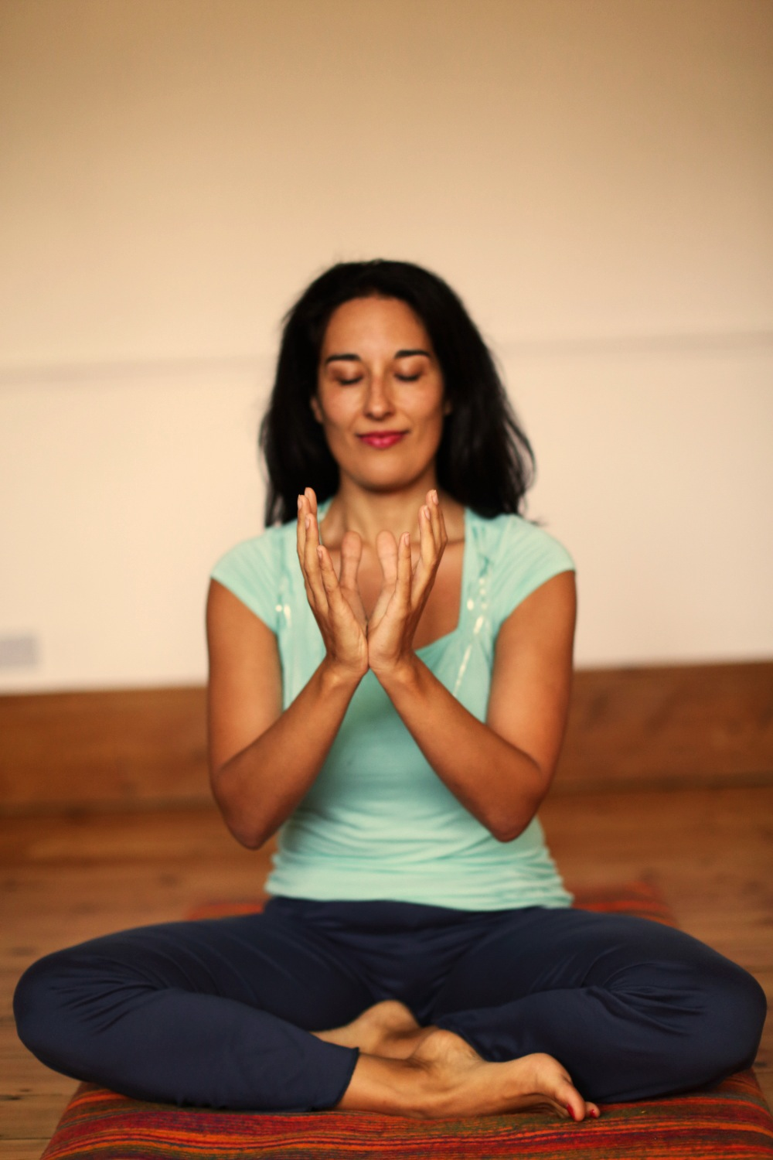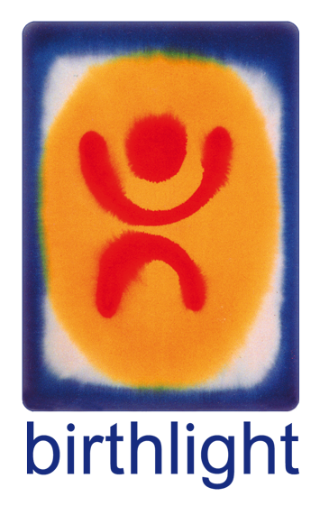

Well Woman Yoga

# Contact details and more info here

### Birthlight Well Woman Yoga

* Draws on the ancient Indian health system of Ayurveda.
* Gentle yet effective micro-stretches and restorative practices accessible to all women.
* Promotes hormonal balance   
  and vitality.
* Helps stabilise hormone levels
* Addresses body and mind together at all stages of women’s reproductive cycle to release tension and reduce anxiety.
* Improves blood flow to pelvic region, postural alignment, muscle tone, bone loading and body balance.
* Creates a supportive environment for women of mixed ages.

Company name and/or logo

### www.birthlight.com

# **Well Woman Yoga Class**

# Day

# Time

# Place

# **Well Woman Yoga Class**

# Day

# Time

# Place

With teacher’s name

[web address]