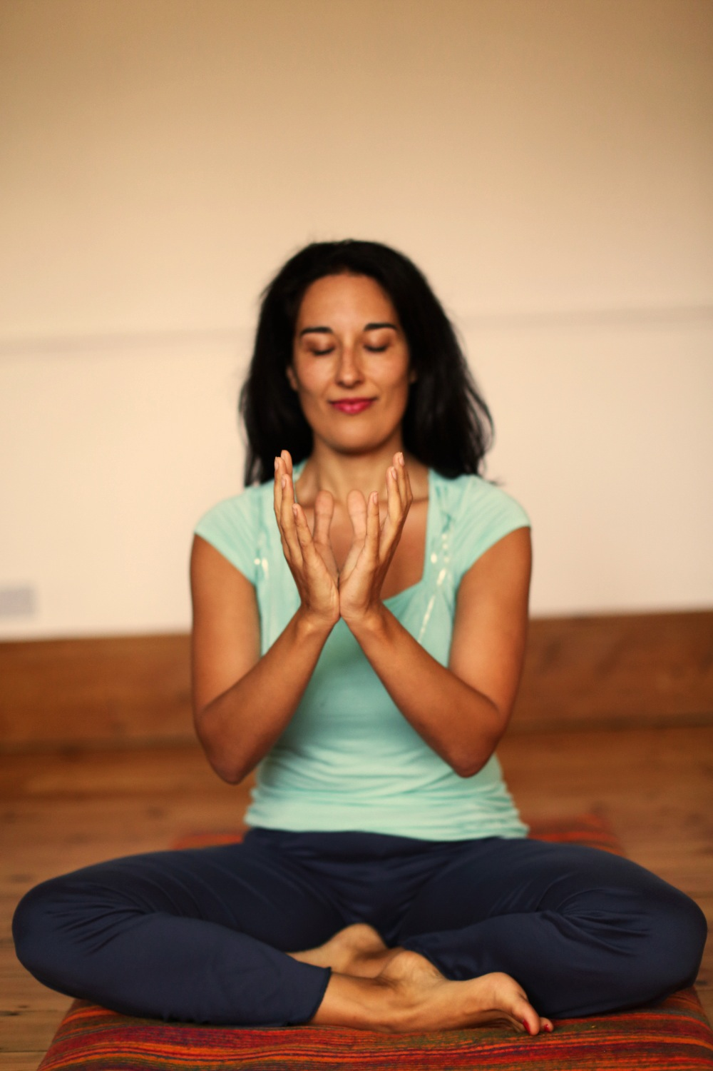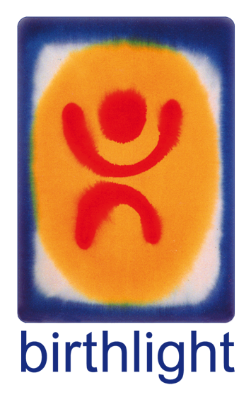

Fertility Yoga

### www.birthlight.com

### Birthlight Fertility Yoga

* Yoga adaptations for natural stimulation of ovarian function and for optimal womb ecology.
* Body, mind and spirit resources drawn from yoga to help with stress.
* Self-nurture and relaxation.
* Focus on creating space and ease and on optimising blood flow to the lower pelvis.
* Creates a supportive environment for women of mixed ages.
* Offers a safe space to relax and gently start your pregnancy journey in the early days and weeks
* Yoga based practices to prepare for IVF and to support the implantation process.

With teacher’s name

Company name and/or logo

# **Fertility Yoga Class**

# Day

# Time

# Place

# **Fertility Yoga Class**

# Day

# Time

# Place

# Contact details and more info here

[web address]