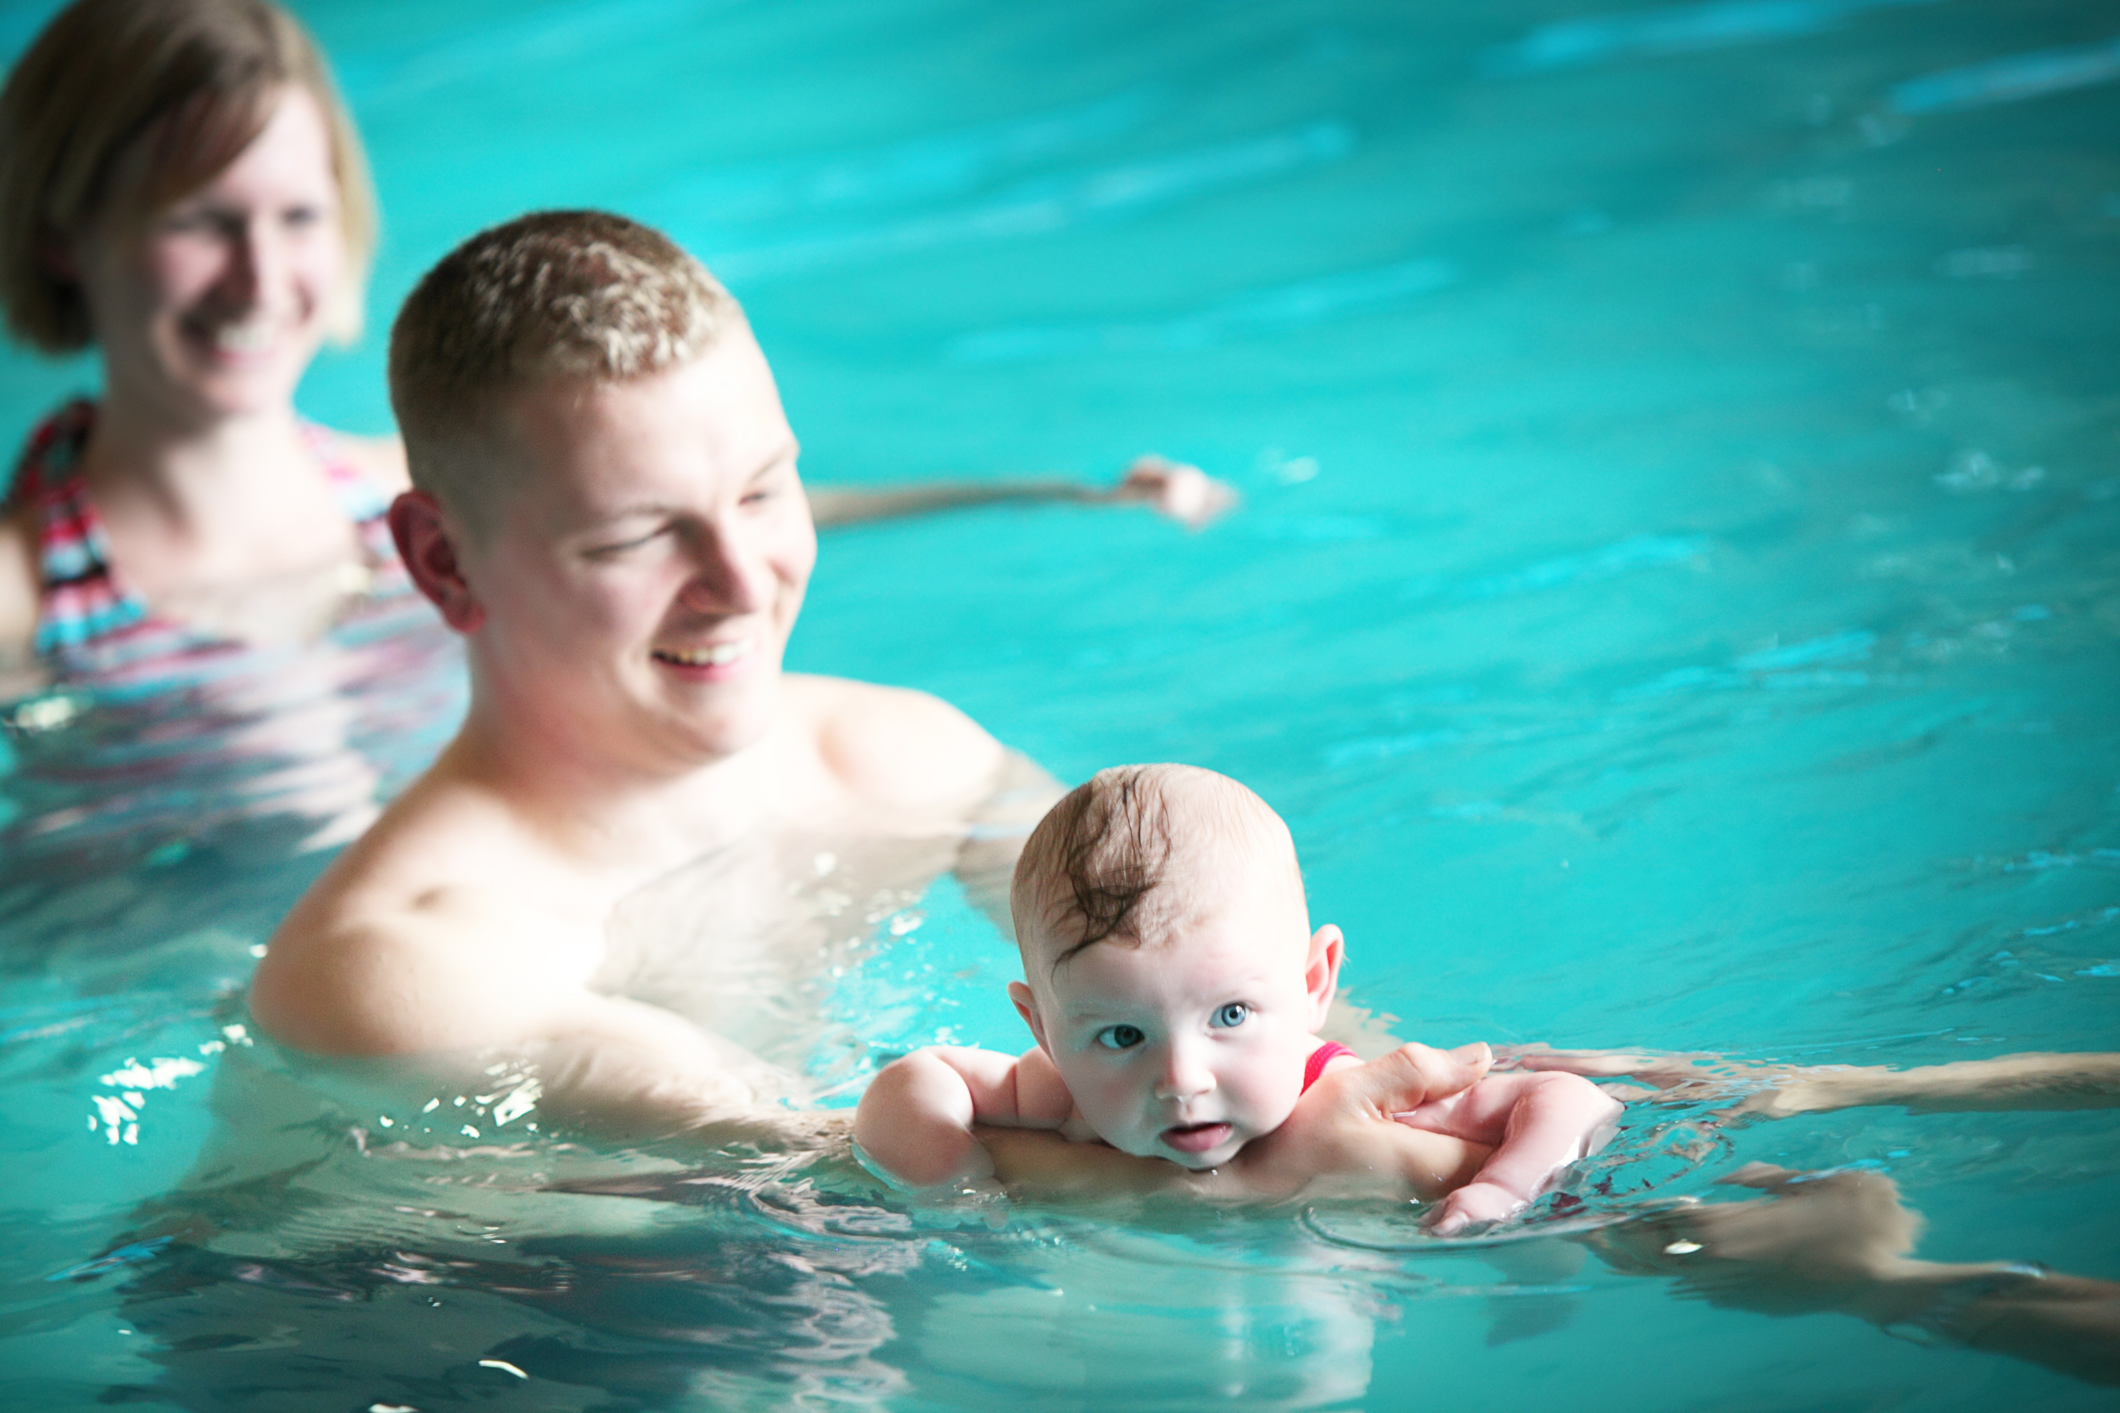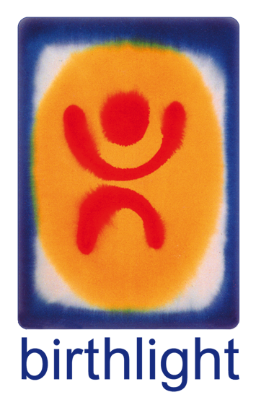

Company name and/or logo

# Contact details and more info here

### www.birthlight.com

### Birthlight Baby Swimming

* Strengthens and helps baby development with acclaimed pioneering interactive parent-baby moves in water.
* Promotes baby confidence in water in playful and constructive ways.
* Helps develop emotional intelligence.
* Fantastic for father/mother baby bonding.
* Creates circles of friendship in a non-competitive atmosphere.
* Provides the foundations for life-long love of water and health lifestyle.

# **Baby Swimming Class**

# Age Group

# Day

# Time

# Place

# **Baby Swimming Class**

# Age Group

# Day

# Time

# Place

With teacher’s name

Baby Swimming

[web address]